

Information Systems – Design & Development

Session 3

Swing Library – User Interface

2018/19

3 sessions (6 hours)

Objetives

Learn to design a desktop application in graphical mode to interact with an Oracle database

Exercise 1

Create a main window with this menu bar:

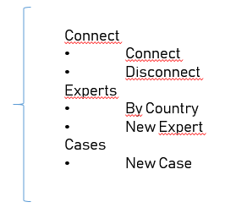

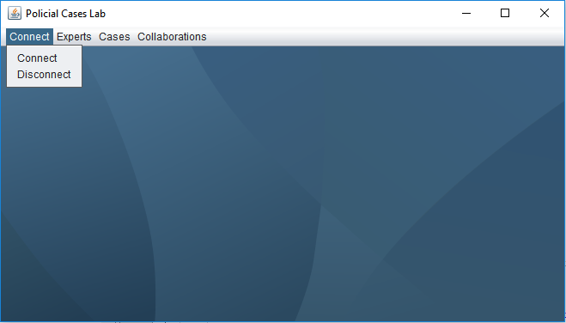

Exercise 2

When you open the window “new Expert” the system will show something similar to:

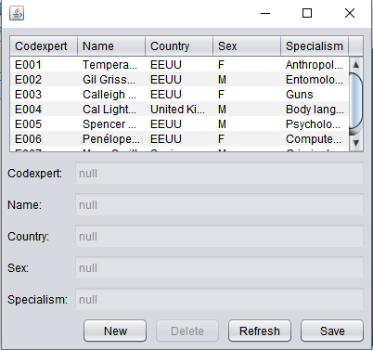

Exercise 3

When you click on Expets by Country, the system will show:

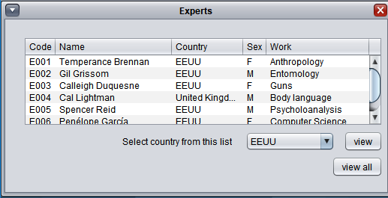

Exercise 4

When you click on Cases new Case, the system will show a similar screen as in Exercise 2 but for cases.

